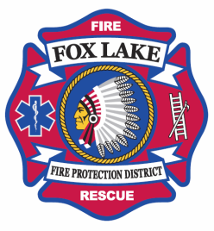 The Fox Lake Fire Protection District Presents: “SAVING LIVES” Program 2017-18
“Chain of Hearts”
Goal: Preparing our community to know what to do if someone has Sudden Cardiac Arrest (SCA).

Our department would like to reach out to the community to educate people on how to participate, join & continue the Chain of Hearts in Fox Lake.

Did you know?
Sudden Cardiac Arrest is among the leading killers of Americans, claiming an estimated 350,000 people each year. More people die of SCA than breast, lung, colon, and prostate cancer combined.
Research shows that communities with higher bystander CPR participation have higher SCA survival rates.

What does this program entail? FREE community bystander CPR and AED. A short demo video will be shown followed by hands on practice. Time: 30 minutes, this is not a certified class through AHA.

How do I sign up? Email Kim VanHoorelbeke at kvan@flfpd.org
(Groups, Business’s, Clubs, etc. are all encouraged to sign up as well)

The first few minutes could make a lifetime of difference before an ambulance/help arrives!

Please join us in becoming a participant in the “Chain of Hearts”. Each participant will receive a participant decal.
